Rivers Women Cooperative Federation Alliance Strengthens Members’ Capacity on Resource Governance
…Call for access to economic opportunities for women empowerment
…Needs Assessment For Community Development
By Constance Meju
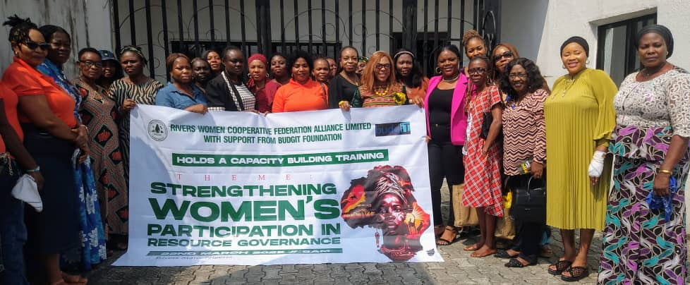
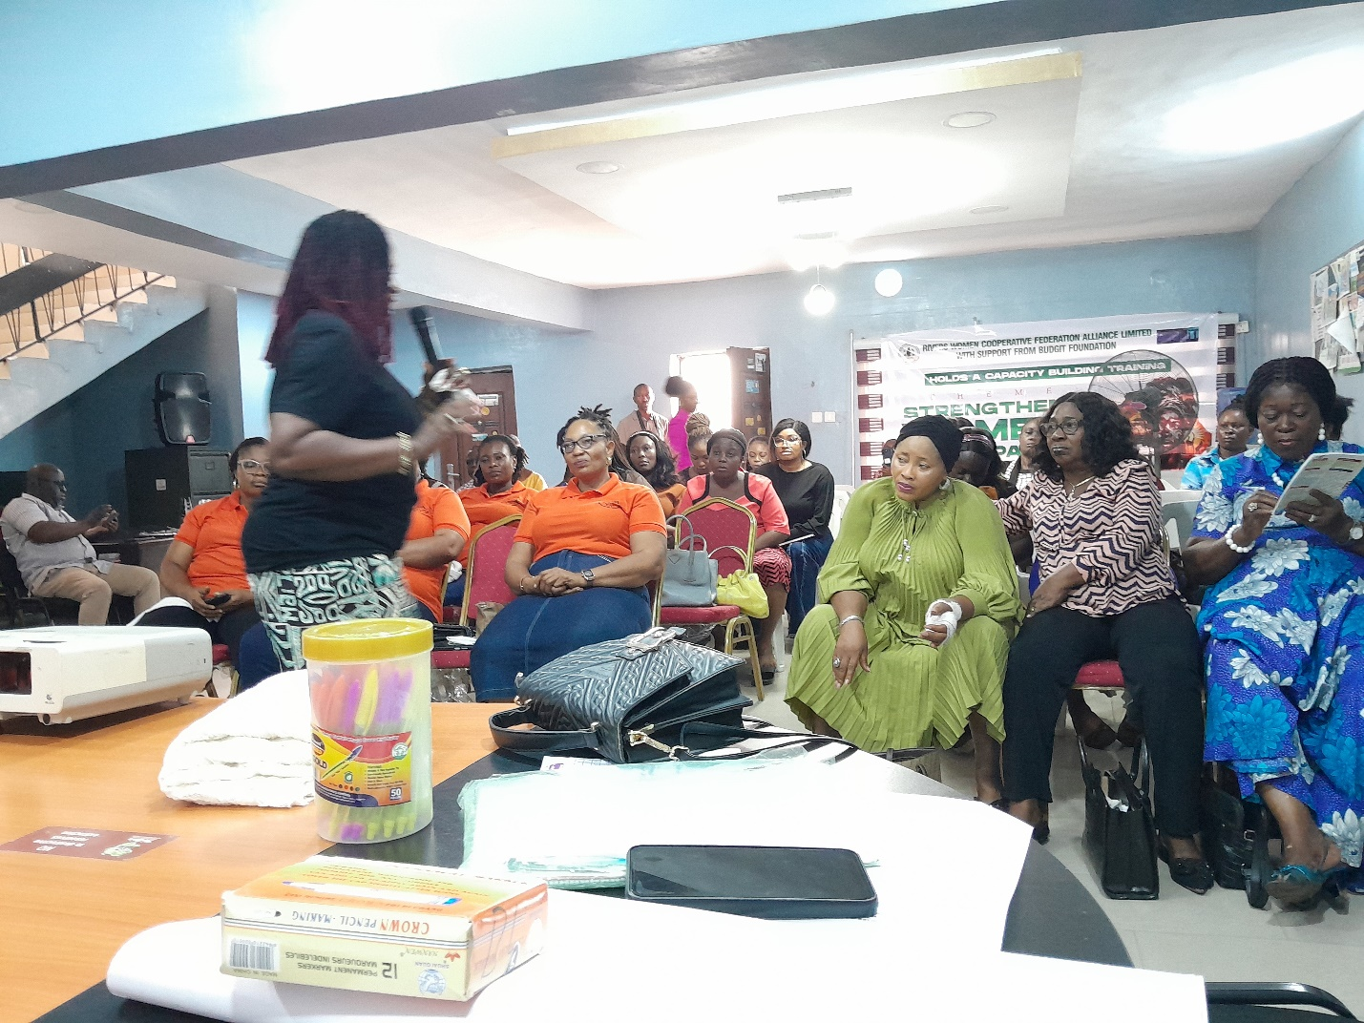
Idongesit Smart discussing gender equality and inclusion matters with the Rivers Women Cooperative Federation Alliance Ltd members

The Rivers Women Cooperative Federation Alliance Ltd has strengthened the capacity of its members for better performance. It held a one-day training tagged, ‘Capacity Training on Strengthening Women’s Participation in Resource Governance’ on Saturday, March 22 at the Kebetkache Women Development and Resource Center hall in Port Harcourt, Rivers State.
The training featured a presentation on ‘Mainstreaming Gender Equality and Social Inclusion for Community Development,‘ and ‘Developing Community Needs Assessment for Host Community Development’.
Delivering her presentation on Gender Equality and Social Inclusion, Mrs Idongesit Smart, senior programme officer with Kebetkache stressed, that for development to be progressive and sustainable, both the male and female gender should receive equal treatment and all segments of society including persons with disability, the aged, women, men and youth, should be mainstreamed into policy planning and access to opportunities.
She stressed that women have rights like men and those, rights should be protected .She charged women to build up their economic power, speak up and unite to defend their rights.
Idongesit challenged women to seek economic opportunities to become self-reliant and strong enough to speak up while the women agreed that it is imperative that parents begin to give their male and female children same training and attention, to break the partriachal jinx that has continued to act as barriers against women and girls.
In his presentation on ‘Developing Community Needs Assessment for Host Community Development,’ Henry Eferegbo highlighted the absence of women in the management of community resources noting that the presence of women in decision making can bring higher benefits to not just women but the society at large.
He advised the cooperators to work with a better understanding of the people living where they operate for successful project execution. The executive director of OLEGH pointed out that properly identifying community needs, rather than working on assumed desired needs, encourages community trust and buy-in which promote sustainable development.
Eferegbo further advised the women to build themselves into a strong voice that will advocate for more empowerment for women.
The programme was organized with funding support from Budgit Foundation and participants confirmed acquiring useful knowledge from the very active training.

